**Practical-1:** Introduction of Figma and basic tools.

**Definition:** Create the design using the Figma Design Tools, Position, Size, Rotation, & Corner Radius properties.

**Solution:**

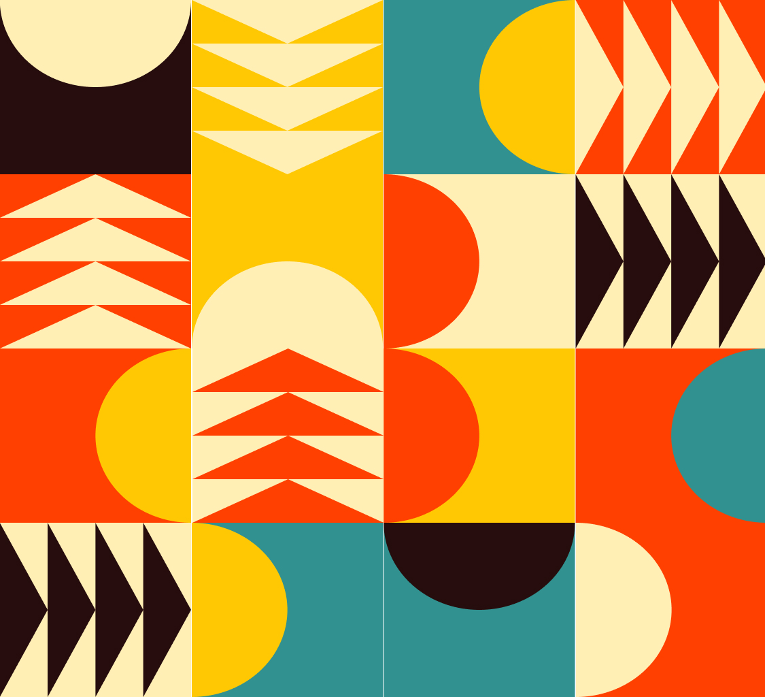

**Working:**

* First, open Figma. Add a new Figma design file.
* Rename a file as 133_Practical-1_GeometricShapes.
* In this design, the following tools are used for a particular operation:
* Export your design as a PNG file.

|  |  |  |
| --- | --- | --- |
| **Tools Name** | **Use** | **Properties** |
| Frame Tool (F) | The frame is used as a container for this geometric shapes design. | Width: 768px, Height: 843px Color fill: #FFFFFF Corner Radius: 0px Blend mode: Pass Through |
| Rectangle Tool (R) | Used to create square or rectangular blocks for dividing the whole screen into a grid. These blocks help in placing other shapes. | Size: Around 192px × 192px (adjust as needed to fit evenly in the frame) Fill colors used: #F6471D, #F8C400, #318C8E, #FAE9A6, #2D1A1A No stroke Rename layers as “Tile_1”, “Tile_2”, etc. |
| Ellipse Tool (O) | Used to draw circles or half circles for decorative shapes overlapping the tiles. | Hold Shift to draw perfect circles. Diameter about 192px To make a half-circle: draw a circle and subtract half using a rectangle and Boolean Subtract. Use colors from the above palette. Rename layers like “HalfCircle_Left_Yellow.” |
| Polygon Tool (Y) | Used for making triangles that create arrow or chevron patterns in the design. | Sides: 3 Rotate angles: 0°, 180°, etc. Size around half of a tile (about 96px wide) Fill colors: #FAE9A6, #2D1A1A, etc. Rename layers like “Triangle_Up_Cream.” |
| Boolean Operations | Used to cut or combine shapes, for example to make half circles. | Operations used: Union, Subtract, Intersect, Exclude Example: subtract half of a circle to make a half-circle shape. |
| Align & Distribute Tools | Used to arrange shapes properly inside the grid and keep equal spacing. | Use Align horizontally and vertically, or distribute spacing between shapes. Shortcuts: Shift + A for auto layout, Shift + H or Shift + V for alignment. |
| Rotation Tool | Used to rotate triangles or other shapes so they face the right way. | Rotate to angles like 0°, 90°, 180°, etc. as needed for repeating patterns. |
| Layer Rename | Helps keep the Figma file neat by naming layers based on what they are. | Examples: “Tile_Orange”, “HalfCircle_Right_Teal”, “Triangle_Down_White”, etc. |
| Export Tool | Used to save the finished design as an image for submission. | Go to File → Export → JPG or PNG Choose your preferred resolution and quality. |